EJERCICIOS LDAP+NFS

1-
sudo mkdir /moviles
sudo chown nobody:nogroup /moviles
sudo chmod -R 777 /moviles
sudo echo "/moviles *(rw,sync,no_root_squash,no_subtree_check)" >> /etc/exports
sudo systemctl restart nfs-kernel-server.service
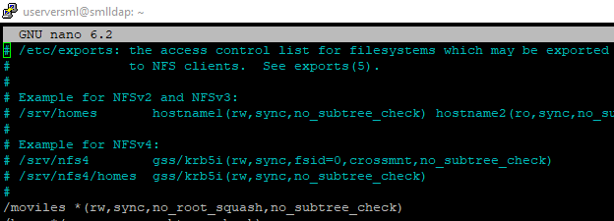
2-
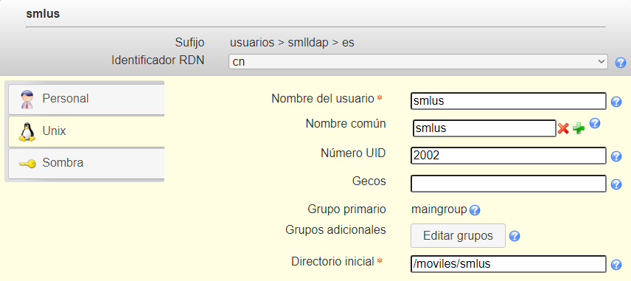
3-

